AN EXPLORATORY ANALYSIS OF THE 2019 NIGERIAN IMPORT

DATA

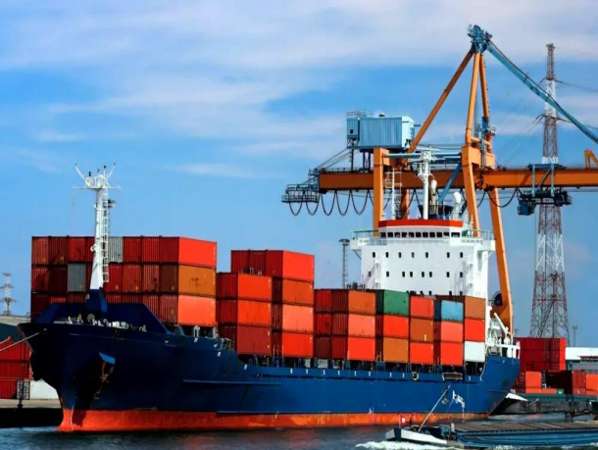

**GROUP 2**

**HerTechTrail Data Analytics Pro Track**

20.10.2022

**INTRODUCTION**

**Background of Study**

As at 2018, Nigeria was the fifth largest importer in Africa with imports covering 6.6% of the total share in Africa. The dataset used was compiled by Godwin Abah through the Central Bank of Nigeria. It contains the raw data for all importation of goods into Nigeria from January 2019 to December 2019. The dataset includes details on the type of goods imported, the importers’ detail, the exporters’ detail, the commercial bank through which the trade was facilitated, the payment mode, the description, size and cost of each good.

**Aim and objectives of the project**

This project aims to gain an understanding of the import activities in Nigeria.

The objectives of the project include the following:

● To generate insights that will be useful for current and prospective importers.

● To identify the top export trading companies patronized by companies in Nigeria.

● To provide insights into banks that facilitate the most trades for importers in Nigeria.

**Roadmap of the project**

| S/N | STEP | DESCRIPTION |
| --- | --- | --- |
| 1 | Data Gathering | This step involved sourcing data for the analysis. |
| 2 | Data Assessment | This step involved evaluating data to ensure the quality and tidiness of the dataset. |
| 3 | Data Cleaning | This involved fixing every issue highlighted in step 2 [Data Assessment] to further ensure the dataset was ready for analysis without constraints. |
| 4 | Data Analysis | Here, the data was analyzed to meet the aim and objectives of the project. Questions were raised, codes were run, and insights were generated. |

5 Data Visualization This step involved the use of charts to represent the analyzed data.

**STEP SPECIFICATIONS**

**Project Approach**

● Data Gathering

The team sourced for import data to identify and generate insights into the economic importance of import trends within Nigeria for both current and prospective importers.

1

The 2019 Nigerian Import Data was downloaded from Kaggle as an Excel file. To access this data, the Excel file was read and saved in a dataframe called ‘‘imports’’.

#Loading the dataset

imports = pd.read_excel('2019 NIGERIAN IMPORT DATA.xlsx')

● Data Assessment

Following the loading of the dataset, the team determined to assess the data to ensure that it was free from data quality and tidiness issues.

To do this, some codes were run as shown below:

1. #getting information about the different columns for data types and presence of missing values imports.info()

2. #checking for duplicates

imports.duplicated().sum()

3. #data summary statistics

imports.describe()

After assessing the data, the following issues were observed:

1. Data Quality Issues

○ Inaccurate data type (APP_YEAR)

○ Missing values (Bank code, Bank name)

○ Non-descriptive/Incorrectly spelt column name (BNK_NAM)

2. Data Tidiness Issues

○ Presence of some null rows

○ AUTHORIZED_DEALER_DATE column can be divided into distinct columns (day, month)

● Data Cleaning

At this stage, we dealt with the data quality and tidiness issues identified during the data assessment. Before the cleaning was performed, a dataframe was created to work on so as not to lose any data from the original dataset. The python code for this is displayed below:

#making a copy of the dataset which will be cleaned to preserve the original

imports_clean = imports.copy()

Each issue was successfully dealt with using the codes shown in the notebook.

● Data Analysis

This step was carried out after the data cleaning. Here, seven (7) questions were raised. They include: 1. What are the top banks used by importers in Nigeria?

2

2. What is the most used currency for importation into Nigeria?

3. What is the best time to import based on the price of dollars?

4. What months experience increased import traffic?

5. Who are the top importers (companies) in Nigeria and what do they import?

6. What is the most and least expensive item imported?

7. What payment methods are available?

The codes are available in the notebook here

These seven (7) questions were given more importance in the analysis as they answer the most likely questions raised by importers (companies and enterprises) within Nigeria.

● Data Visualization

The last but definitely not the least step. An equally important phase in the project, the visualization helps with easier readability and understanding of the analysis phase. Each question was answered using the visuals displayed below:

1. What are the top banks used by importers in Nigeria?

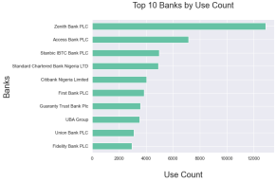

Fig. 1: Top 10 Banks Used by Importers in Nigeria

Zenith Bank was the most used bank for import transactions while FBNQuest Merchant Bank was the least patronized.

2. What is the most used currency for importation into Nigeria?

3

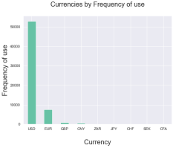

Fig. 2: Frequency of Currencies Used

The US dollar was the most used currency with a frequency of over 50,000 while the least used was CFA with a frequency of 1

3. What is the best time to import based on the price of dollars?

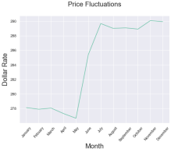

Fig. 3: Naira-Dollar Rate Fluctuations from January to December

The lowest dollar rate occurred in May while November has the peak dollar rate.

4. What months experienced increased import traffic?

4

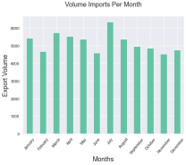

Fig. 4: Volume Imports Per Month

The highest volume of importation was experienced in July

5. Who are the top importers (companies) in Nigeria?

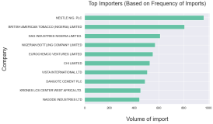

Fig. 5: Top 10 Importing Companies

Nestle Nig. Plc imported the largest volume of goods.

6. What is the most and least expensive item imported?

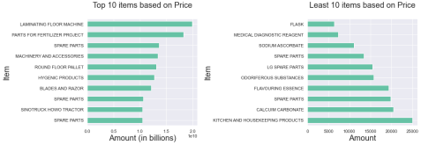Fig. 6a: 10 Most Expensive Imported Items Fig. 6b: 10 Cheapest Imported Items Certain machines and spare parts were the most expensive imported items Flask happened to be the cheapest imported product

5

7. What payment modes are available?

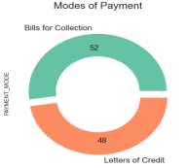

Fig. 7: Available modes of payment

The two available modes of payment are Bills for Collection and Letters of Credit

**Execution**

Project tools and libraries

The assessment, cleaning, analysis, and visualization of the dataset were performed using **Jupyter notebook**. To perform the above-listed steps the following libraries were imported:

● Pandas

● Matplotlib

● Seaborn

#importing the necessary libraries and setting the plots to be embedded inline

import pandas as pd

import matplotlib.pyplot as plt

import seaborn as sns

%matplotlib inline

**Implementation**

Development approach

Team members were to source for datasets on Kaggle. Over 10 datasets were submitted, two of which were identified to be more impactful. A conclusion was reached on working with the Nigerian import data after a vote was cast between the two datasets.

6

Team member roles

● Data Gathering – All team members

● Data Assessment – Wofai & Grace

● Data Analysis & Visualization – Grace, Wofai & Tomisin

● Report Writing – Peace, Chidinma & Rahmotallah

● Slide Preparation - Sinmi & Ogechukwu

● Coordination & Compilation - Grace

Implementation Process (achievements, challenges, decision to change something)

Concluding on a dataset was quite challenging initially. The team was able to clean, analyze and visualize the data. Insights were obtained from the analysis which can help importers and prospective importers make informed decisions on items to import, banks to use in making transactions, potential exporters to buy from, and the best time to import, among others.

Implementation Challenges

Getting the items that were imported the most proved a bit difficult because the 'ITEMS' column had items with very descriptive names. A column that grouped each item into categories based on uses might have been very helpful in getting the category of the item that was imported more.

Also, the address column would have been useful for getting the address but it proved difficult to do using str.rfind and str.slice.

**RESULTS**

Upon careful analysis of the dataset and based on the questions raised, the following findings have been deduced:

1. Zenith Bank is the most used bank for trade operations while FBNQuest Merchant Bank provided the least financial services for import activities.

2. The most used currency for import trades into Nigeria is USD. This suggests two things; (i)Most goods were imported from the USA or countries in which USD is the primary currency. (ii)The USD is the most widely accepted trade currency in the world, whether or not it is a country’s primary currency.

3. January to May is considered the best time for import trades. This is a result of the lower exchange rate of the Nigerian Naira (NGN) to the United States Dollar (USD) within that time frame as shown in the visuals. 4. The exchange rate starts increasing from the month of May and peaks in November.

5. July records the most import activity into Nigeria.

6. Nigeria’s highest importer is Nestle Nig Plc.

7. The FUGAZ Banks - Nigeria’s top 5 banks - are major players in import trade operations in Nigeria. A no-brainer.

8. Some machines and spare parts were the most expensive imported items. This will provide importers and potential importers who have enough and are interested in top items with an idea of the prices of these items. However, flask was the cheapest item among others. Potential importers who do not have enough can start an importation business with any of these cheap items.

9. Bills for collection and Letter of Credit are the most used payment modes because they are the safest trade 7

operations payment mode for both importer and exporter. A possible reason why Bills for collection is used more is the cost of issuing a Letter of Credit is higher than that of Bills for collection.

**CONCLUSION**

The volume of imported goods peaked in the month of July. This can be said to be a major contributing factor to the spike in the Dollar-Naira exchange rate in Nigeria. Zenith’s role as the top bank in import trade operations in Nigeria is an indicator of its profitability as a bank - an insight that other banks can glean from. The FUGAZ (First, UBA, GTB, Access, and Zenith) Banks are among the top ten banks facilitating import trades into the country, Nigeria. This helps to identify major players of trade operations in Nigeria for new importers to consummate a banking relationship.

Nigeria’s top 10 importers (companies) are also an indicator of the most consumed goods within the country, food and beverage being at the top. Whilst this may be good for business, it’s an indicator of the nation’s heavy reliance on foreign produce. This, in addition to the large volume of import activities, is telling on the Naira’s valuation and high rise in the exchange rate between the naira and foreign currencies, especially the US Dollar (USD).

Although this project is focused on the 2019 import dataset, these insights can guide current and prospective importers, which is the major aim of the project.

**REFERENCES**

1. https://www.kaggle.com/datasets/godwinabah/2019-nigerian-import-data

2. https://www.statista.com/statistics/1193043/africa-s-largest-importers-by-country/

8